Project Title: Smart Fashion Recommender Application Project Design Phase-I - Solution Fit Template Team ID: PNT2022TMID14116

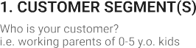

Online shopping gives New Collections

pros: Easy to use

cons: customer confused when have lost of collections

Money and Network Connection

The Customers are Adults and children

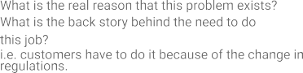

Customers need to be with new fashions for current trends

Customers spend the time to find the new fashion clothes

Users hard to find Trending Fashion Clothes.

|  |  |  |  |  |
| --- | --- | --- | --- | --- |
|  | **3. TRIGGERS TR**  What triggers customers to act? i.e. seeing their neighbour installingsolar panels, reading about a more efﬁcient solution in the news.  Seeing neighbor Dressing Styles | **10. YOUR SOLUTION SL**  If you are working on an existing business, write down your current solution ﬁrst,ﬁll in the canvas, and check how much it ﬁts reality.  If you are working on a new business proposition, then keep it blank until you ﬁll inthe canvas and come up with a solution that ﬁts within customer limitations, solves a problem and matches customer behaviour. | 1. **CHANNELS of BEHAVIOUR CH**    1. **ONLINE**   What kind of actions do customers take online? Extract online channels from #7   * 1. **OFFLINE**   What kind of actions do customers take ofﬂine? Extract ofﬂine channels from #7and use them for customer development. |  |
| **4. EMOTIONS: BEFORE / AFTER EM**  How do customers feel when they face a problem or a job and afterwards?  i.e. lost, insecure > conﬁdent, in control - use it in your communication strategy & design.  Felling Sad and Frustration > Selfconfident | Make a ChatBot Assistant for shopping with customers and send notifications when new collections arravied | ONLINE: Customers buy the new clothes  OFFLINE: Customers will use the clothes |